House Price Dataset for Regression Models
Dataset of housing features for predicting residential property prices.
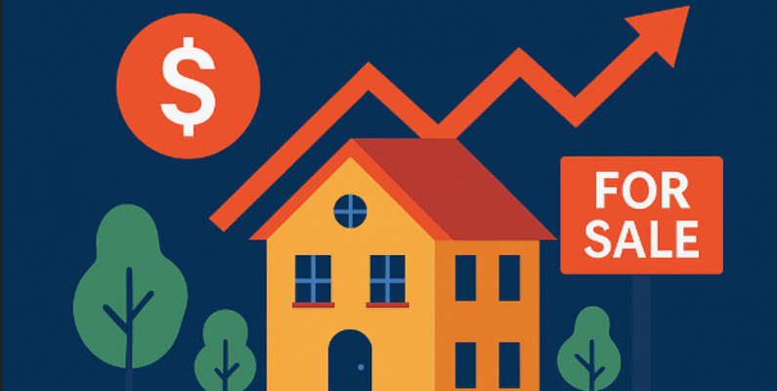
House Price Dataset for Regression Models
🏡 About the Dataset
This housing dataset provides detailed information on residential properties along with their market selling prices, making it perfect for ML regression projects, EDA, and price prediction models.
Each record includes a rich set of features:
🏠 Structural Features
- 📐 Area (sq. ft.)
- 🛏 Bedrooms
- 🚿 Bathrooms
- 🏛 Stories
🚦 Location & Accessibility
- 🛣 Main road access (yes/no)
- 📍 Preferred area (yes/no)
🛋 Amenities & Utilities
- ❄️ Air conditioning
- 🔥 Hot water heating
- 🚪 Guest room
- 🏚 Basement
- 🅿️ Parking
🪑 Furnishing Status
- Furnished 🛋
- Semi-furnished 🪑
- Unfurnished 📦
🎯 Target Variable
- 💰 Price of the house

📊 Why This Dataset Is Useful
This dataset is ideal for:
- 🔮 Predictive modeling (Linear Regression, Random Forest, XGBoost, Neural Networks)
- 🔎 Exploratory Data Analysis & visualization
- 🧠 Feature engineering practice
- 🏆 ML portfolio projects
- 🎓 Academic assignments & training
With a mix of numerical and categorical features, it gives you a realistic environment for learning data preprocessing, encoding techniques, model evaluation, and building end-to-end ML pipelines.

🔹 Key Performance Indicators (KPIs)
1. Average House Price
- Definition: Mean price of all listed houses
- Purpose: Understand the overall market price level

2. Average Price per Square Foot
- Definition: Total Price ÷ Total Area
- Purpose: Measure property value efficiency based on size

3. Average Number of Bedrooms
- Definition: Mean bedrooms across all houses
- Purpose: Identify the most common house configuration

4. Percentage of Houses with Air Conditioning
- Definition:
Houses with Air ConditioningTotal Houses×100\frac{\text{Houses with Air Conditioning}}{\text{Total Houses}} \times 100Total HousesHouses with Air Conditioning​×100
- Purpose: Analyse demand for comfort-related amenities

5. Furnished vs Semi-Furnished vs Unfurnished Ratio
- Definition: Distribution of furnishing status
- Purpose: Understand customer preferences and market supply mix

🔹 Simple to Moderate Business Analysis Questions
- Does house price increase with area size?
(Compare average price by different area ranges)
- Which furnishing status has the highest average price?
(Furnished vs Semi-furnished vs Unfurnished)
- Do houses with air conditioning have higher prices than those without?
- How does the number of bedrooms impact house price?
(2 BHK vs 3 BHK vs 4 BHK)
- Are houses in preferred areas more expensive than non-preferred areas?

